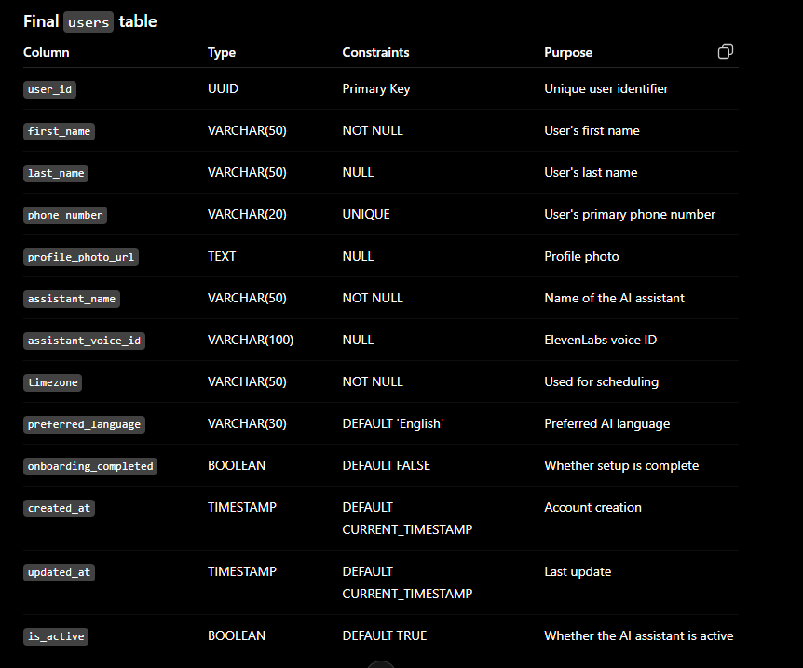

CREATE TABLE users (
user_id UUID PRIMARY KEY,

first_name VARCHAR(50) NOT NULL,

last_name VARCHAR(50) NOT NULL,

phone_number VARCHAR(20) UNIQUE,

profile_photo_url TEXT,

assistant_name VARCHAR(50) NOT NULL,

assistant_voice_id VARCHAR(100),

timezone VARCHAR(50) NOT NULL DEFAULT 'Asia/Kolkata',

preferred_language VARCHAR(30) NOT NULL DEFAULT 'English',

onboarding_completed BOOLEAN NOT NULL DEFAULT FALSE,

created_at TIMESTAMP NOT NULL DEFAULT CURRENT_TIMESTAMP,

updated_at TIMESTAMP NOT NULL DEFAULT CURRENT_TIMESTAMP,

is_active BOOLEAN NOT NULL DEFAULT TRUE
);

User_Preferences:
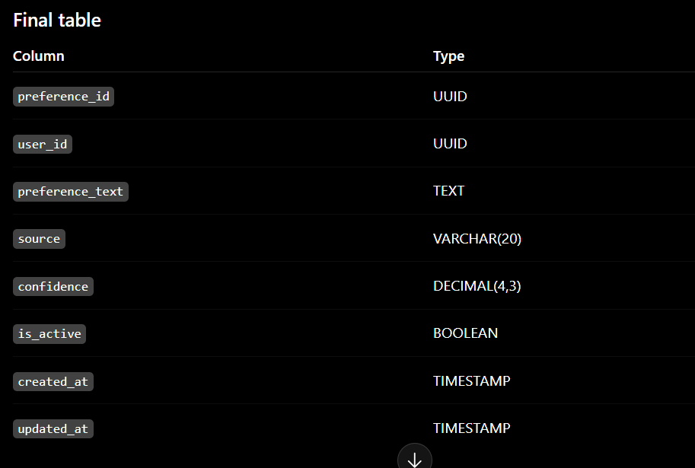
CREATE TABLE user_preferences (
preference_id UUID PRIMARY KEY,

user_id UUID NOT NULL,

preference_text TEXT NOT NULL,

source VARCHAR(20) NOT NULL,

confidence DECIMAL(4,3)
CHECK (confidence >= 0 AND confidence <= 1),

is_active BOOLEAN NOT NULL DEFAULT TRUE,

created_at TIMESTAMP NOT NULL DEFAULT CURRENT_TIMESTAMP,

updated_at TIMESTAMP NOT NULL DEFAULT CURRENT_TIMESTAMP,

CONSTRAINT fk_user_preferences_user
FOREIGN KEY (user_id)
REFERENCES users(user_id)
ON DELETE CASCADE
ON UPDATE CASCADE,

CONSTRAINT chk_preference_source
CHECK (source IN ('CONVERSATION', 'MANUAL'))
);

Priority_contacts table:
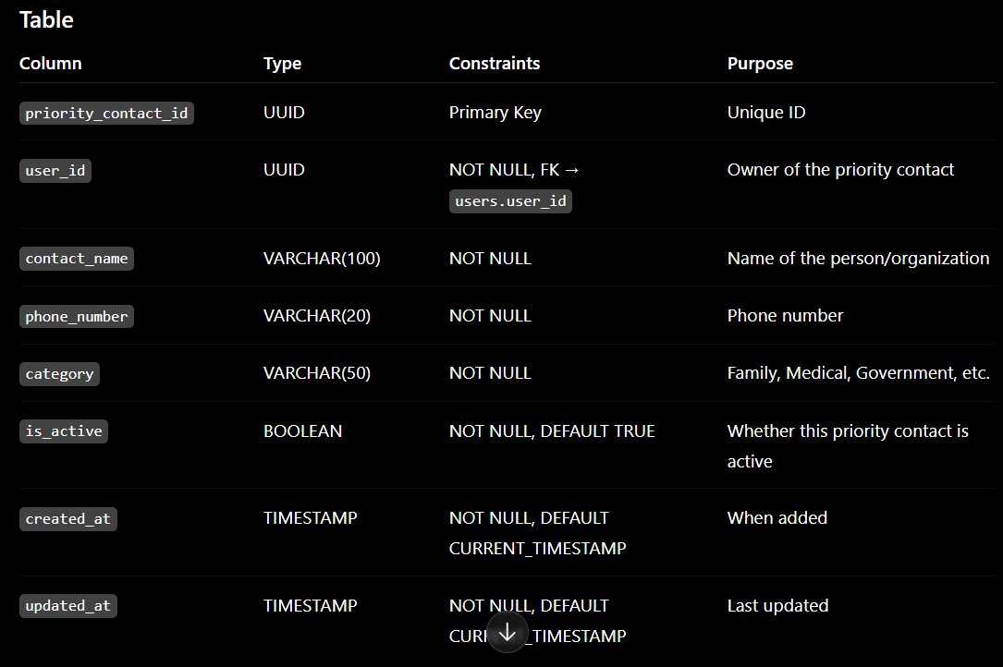
CREATE TABLE priority_contacts (
priority_contact_id UUID PRIMARY KEY,

user_id UUID NOT NULL,

contact_name VARCHAR(100) NOT NULL,

phone_number VARCHAR(20) NOT NULL,

category VARCHAR(50) NOT NULL,

is_active BOOLEAN NOT NULL DEFAULT TRUE,

created_at TIMESTAMP NOT NULL DEFAULT CURRENT_TIMESTAMP,

updated_at TIMESTAMP NOT NULL DEFAULT CURRENT_TIMESTAMP,

CONSTRAINT fk_priority_contacts_user
FOREIGN KEY (user_id)
REFERENCES users(user_id)
ON DELETE CASCADE
ON UPDATE CASCADE
);

Contact table:
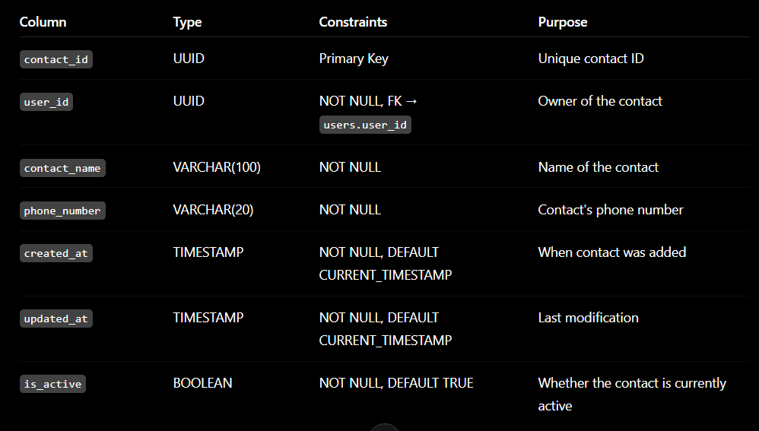
CREATE TABLE contacts (
contact_id UUID PRIMARY KEY,

user_id UUID NOT NULL,

contact_name VARCHAR(100) NOT NULL,

phone_number VARCHAR(20) NOT NULL,

created_at TIMESTAMP NOT NULL DEFAULT CURRENT_TIMESTAMP,

updated_at TIMESTAMP NOT NULL DEFAULT CURRENT_TIMESTAMP,

is_active BOOLEAN NOT NULL DEFAULT TRUE,

CONSTRAINT fk_contacts_user
FOREIGN KEY (user_id)
REFERENCES users(user_id)
ON DELETE CASCADE
ON UPDATE CASCADE
);

Call_History Table:
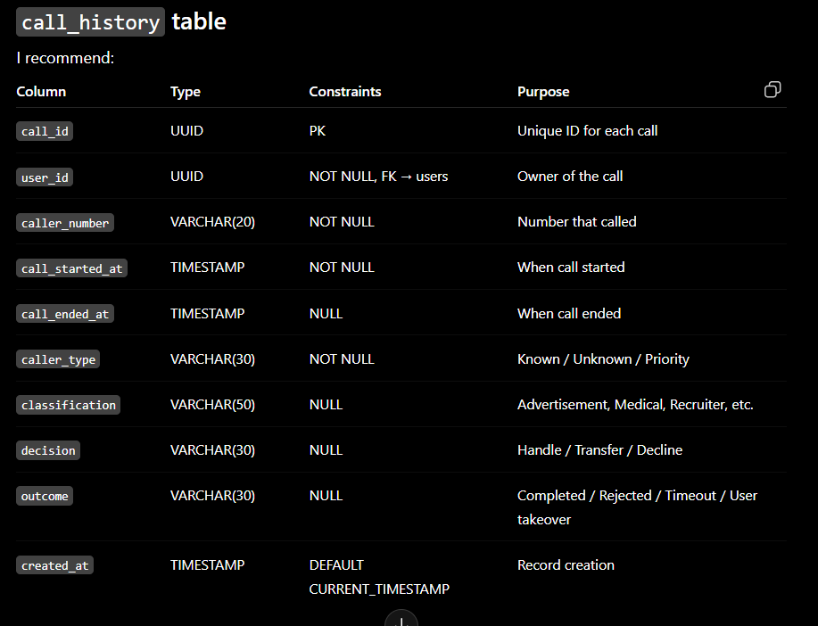

CREATE TABLE call_history (
call_id UUID PRIMARY KEY,

user_id UUID NOT NULL,

caller_number VARCHAR(20) NOT NULL,

call_started_at TIMESTAMP NOT NULL,

call_ended_at TIMESTAMP,

caller_type VARCHAR(30) NOT NULL,

classification VARCHAR(50),

decision VARCHAR(30),

outcome VARCHAR(30),

created_at TIMESTAMP NOT NULL DEFAULT CURRENT_TIMESTAMP,

CONSTRAINT fk_call_history_user
FOREIGN KEY (user_id)
REFERENCES users(user_id)
ON DELETE CASCADE
ON UPDATE CASCADE,

CONSTRAINT chk_caller_type
CHECK (caller_type IN (
'KNOWN',
'UNKNOWN',
'PRIORITY'
)),

CONSTRAINT chk_decision
CHECK (decision IS NULL OR decision IN (
'HANDLE',
'TRANSFER',
'DECLINE',
'ESCALATE'
)),

CONSTRAINT chk_outcome
CHECK (outcome IS NULL OR outcome IN (
'COMPLETED',
'USER_TAKEOVER',
'REJECTED',
'TIMEOUT'
))
);

Conversation_summary table:
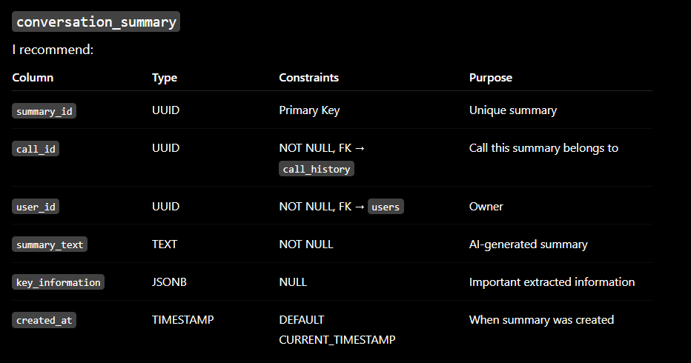
CREATE TABLE conversation_summary (
summary_id UUID PRIMARY KEY,

call_id UUID NOT NULL,

user_id UUID NOT NULL,

summary_text TEXT NOT NULL,

key_information JSONB,

created_at TIMESTAMP NOT NULL DEFAULT CURRENT_TIMESTAMP,

CONSTRAINT fk_summary_call
FOREIGN KEY (call_id)
REFERENCES call_history(call_id)
ON DELETE CASCADE
ON UPDATE CASCADE,

CONSTRAINT fk_summary_user
FOREIGN KEY (user_id)
REFERENCES users(user_id)
ON DELETE CASCADE
ON UPDATE CASCADE
);

Spam_cache table:
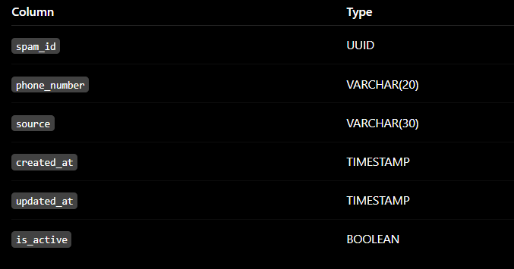
CREATE TABLE spam_cache (
spam_id UUID PRIMARY KEY,

phone_number VARCHAR(20) NOT NULL,

source VARCHAR(30) NOT NULL,

created_at TIMESTAMP NOT NULL DEFAULT CURRENT_TIMESTAMP,

updated_at TIMESTAMP NOT NULL DEFAULT CURRENT_TIMESTAMP,

is_active BOOLEAN NOT NULL DEFAULT TRUE,

CONSTRAINT chk_spam_source
CHECK (source IN (
'TRUECALLER',
'AI_DETECTED',
'USER_REPORTED'
))
);

History_memory table:
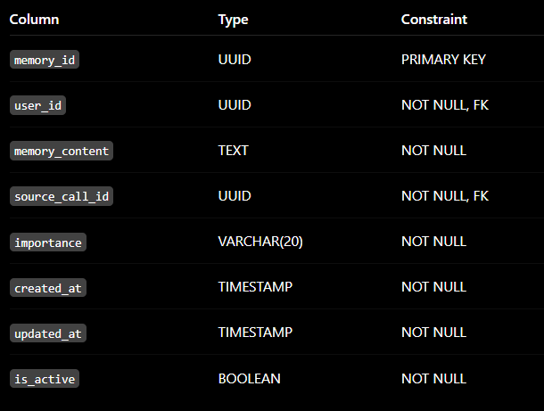
CREATE TABLE historical_memory (
memory_id UUID PRIMARY KEY,

user_id UUID NOT NULL,

memory_content TEXT NOT NULL,

source_call_id UUID NOT NULL,

importance VARCHAR(20) NOT NULL DEFAULT 'MEDIUM',

created_at TIMESTAMP NOT NULL DEFAULT CURRENT_TIMESTAMP,

updated_at TIMESTAMP NOT NULL DEFAULT CURRENT_TIMESTAMP,

is_active BOOLEAN NOT NULL DEFAULT TRUE,

CONSTRAINT fk_historical_memory_user
FOREIGN KEY (user_id)
REFERENCES users(user_id)
ON DELETE CASCADE
ON UPDATE CASCADE,

CONSTRAINT fk_historical_memory_call
FOREIGN KEY (source_call_id)
REFERENCES call_history(call_id)
ON DELETE RESTRICT
ON UPDATE CASCADE,

CONSTRAINT chk_historical_memory_importance
CHECK (importance IN ('LOW', 'MEDIUM', 'HIGH'))
);
Active_memory table:
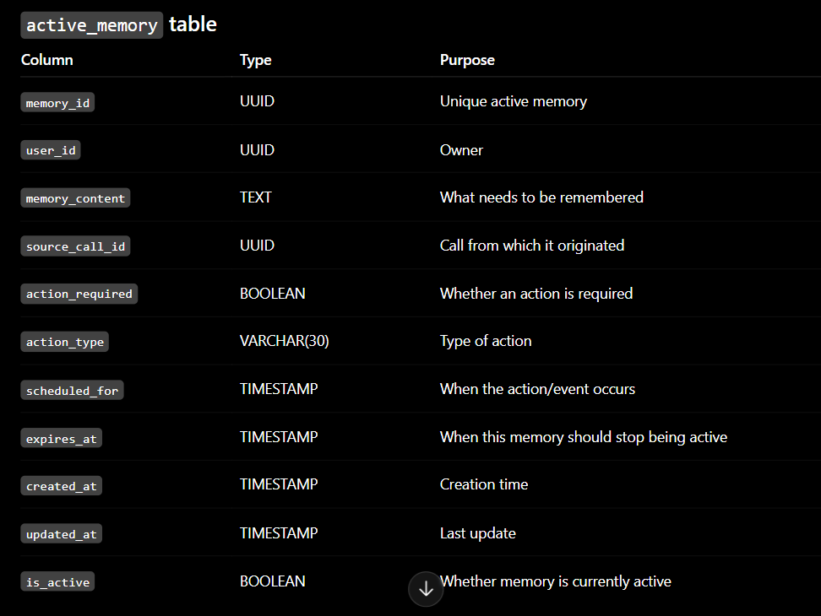
CREATE TABLE active_memory (
memory_id UUID PRIMARY KEY,

user_id UUID NOT NULL,

memory_content TEXT NOT NULL,

source_call_id UUID NOT NULL,

action_required BOOLEAN NOT NULL DEFAULT FALSE,

action_type VARCHAR(20) NOT NULL DEFAULT 'NOTIFICATION',

scheduled_for TIMESTAMP,

expires_at TIMESTAMP,

created_at TIMESTAMP NOT NULL DEFAULT CURRENT_TIMESTAMP,

updated_at TIMESTAMP NOT NULL DEFAULT CURRENT_TIMESTAMP,

is_active BOOLEAN NOT NULL DEFAULT TRUE,

CONSTRAINT fk_active_memory_user
FOREIGN KEY (user_id)
REFERENCES users(user_id)
ON DELETE CASCADE
ON UPDATE CASCADE,

CONSTRAINT fk_active_memory_call
FOREIGN KEY (source_call_id)
REFERENCES call_history(call_id)
ON DELETE RESTRICT
ON UPDATE CASCADE,

CONSTRAINT chk_active_memory_action_type
CHECK (action_type = 'NOTIFICATION')
);

Learned_memory table:
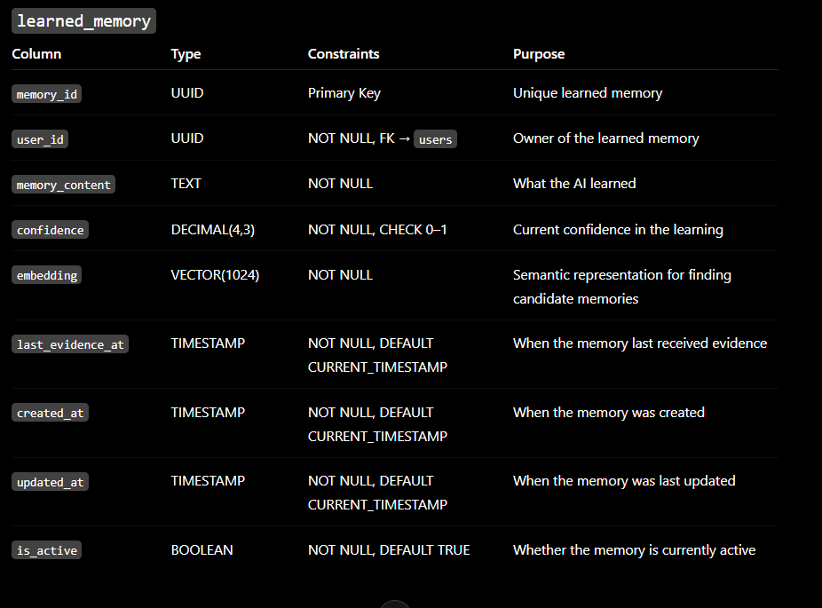

Query:
CREATE TABLE learned_memory (
memory_id UUID PRIMARY KEY,

user_id UUID NOT NULL,

memory_content TEXT NOT NULL,

confidence DECIMAL(4,3) NOT NULL,

embedding VECTOR(1024) NOT NULL,

last_evidence_at TIMESTAMP NOT NULL DEFAULT CURRENT_TIMESTAMP,

created_at TIMESTAMP NOT NULL DEFAULT CURRENT_TIMESTAMP,

updated_at TIMESTAMP NOT NULL DEFAULT CURRENT_TIMESTAMP,

is_active BOOLEAN NOT NULL DEFAULT TRUE,

CONSTRAINT fk_learned_memory_user
FOREIGN KEY (user_id)
REFERENCES users(user_id)
ON DELETE CASCADE
ON UPDATE CASCADE,

CONSTRAINT chk_learned_memory_confidence
CHECK (confidence >= 0 AND confidence <= 1)
);

Learned_memory_sources:
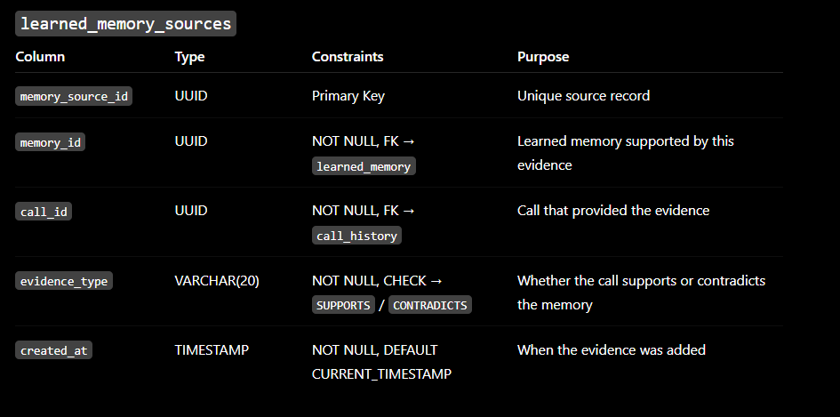
Query:
CREATE TABLE learned_memory_sources (
memory_source_id UUID PRIMARY KEY,

memory_id UUID NOT NULL,

call_id UUID NOT NULL,

evidence_type VARCHAR(20) NOT NULL,

created_at TIMESTAMP NOT NULL DEFAULT CURRENT_TIMESTAMP,

CONSTRAINT fk_memory_sources_memory
FOREIGN KEY (memory_id)
REFERENCES learned_memory(memory_id)
ON DELETE CASCADE
ON UPDATE CASCADE,

CONSTRAINT fk_memory_sources_call
FOREIGN KEY (call_id)
REFERENCES call_history(call_id)
ON DELETE RESTRICT
ON UPDATE CASCADE,

CONSTRAINT chk_memory_source_evidence_type
CHECK (evidence_type IN ('SUPPORTS', 'CONTRADICTS')),

CONSTRAINT uq_memory_call
UNIQUE (memory_id, call_id)
);

Notifications table:
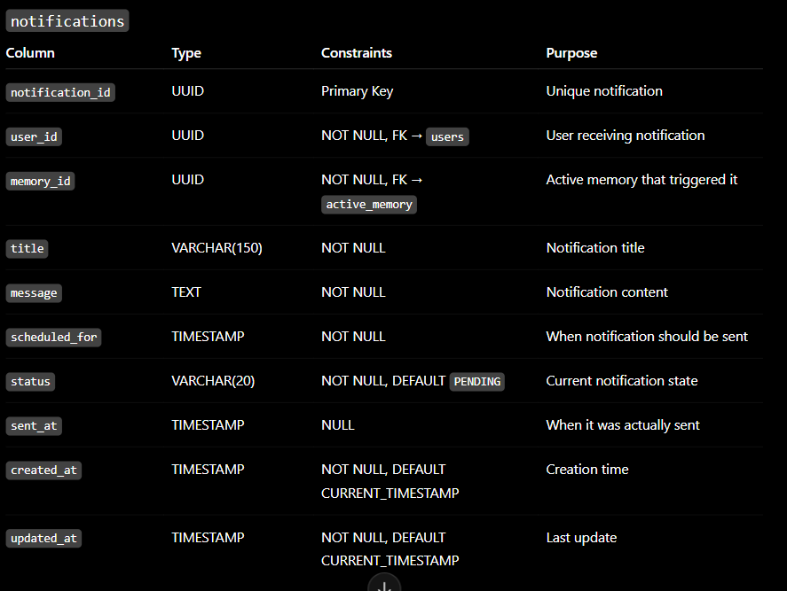
CREATE TABLE notifications (
notification_id UUID PRIMARY KEY,

user_id UUID NOT NULL,

memory_id UUID NOT NULL,

title VARCHAR(150) NOT NULL,

message TEXT NOT NULL,

scheduled_for TIMESTAMP NOT NULL,

status VARCHAR(20) NOT NULL DEFAULT 'PENDING',

sent_at TIMESTAMP,

created_at TIMESTAMP NOT NULL DEFAULT CURRENT_TIMESTAMP,

updated_at TIMESTAMP NOT NULL DEFAULT CURRENT_TIMESTAMP,

CONSTRAINT fk_notifications_user
FOREIGN KEY (user_id)
REFERENCES users(user_id)
ON DELETE CASCADE
ON UPDATE CASCADE,

CONSTRAINT fk_notifications_memory
FOREIGN KEY (memory_id)
REFERENCES active_memory(memory_id)
ON DELETE RESTRICT
ON UPDATE CASCADE,

CONSTRAINT chk_notification_status
CHECK (status IN (
'PENDING',
'SENT',
'CANCELLED',
'FAILED'
))
);

